Introduction:
This paper analyses the strategy of a well-known pharmacological organization "McKesson" in the United States through Strategic analysis tools like SWOT and PESTLE. Both analysis in Appendix A. Initially, the paper demonstrates the business unit level of the company. Then, both strength and inhibitor factor that affect the strategic business unit will discuss how to discover the opportunities to maintain the company growth and sustainability.

The definition of the business unit level:
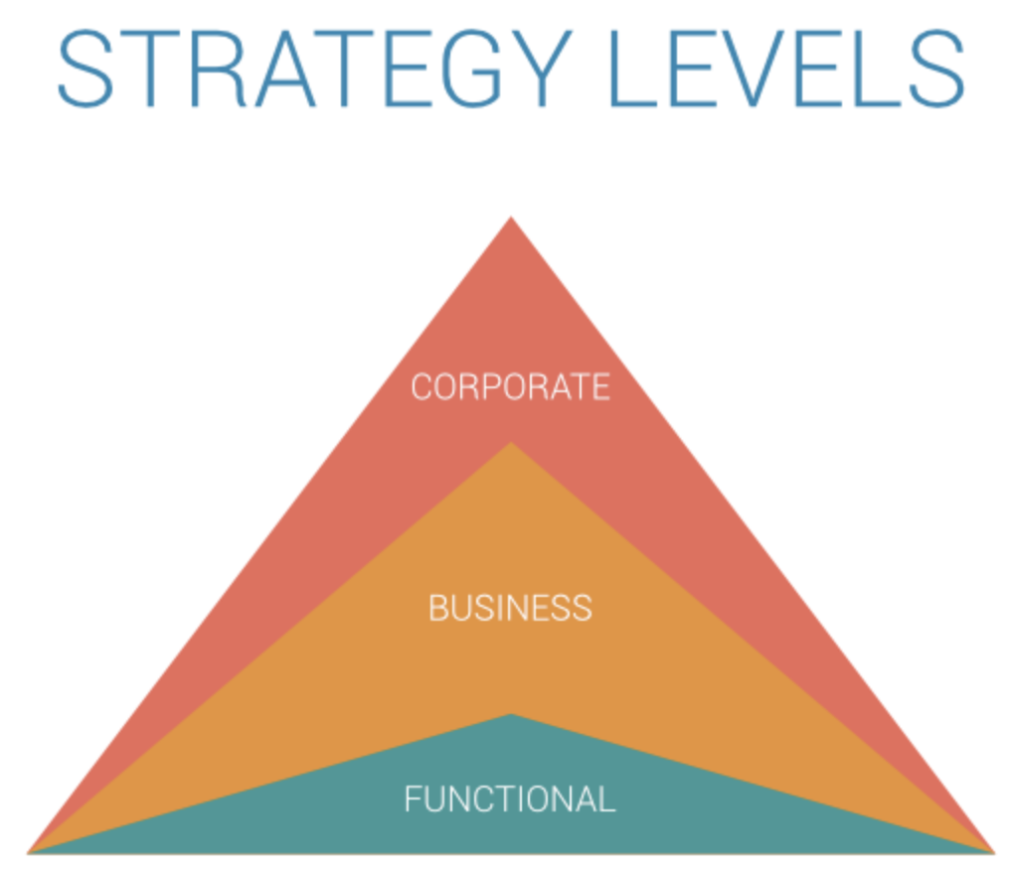
Initially, to understand the McKesson business unit strategy, elaboration of the business unit level definition and the related business term should be highlighted and understood well for a clear description of the McKesson strategic business unit. In the hierarch of the strategy levels, there are three strategic levels, as shown in Figure 1 (Wright, 2019). The corporate level determines which business market the organization will compete in and give directions for the whole organization. While the business level strategy processes the activities and actions that direct specific business within the organization. Finally, is the Functional level strategy, which plans their strategic objectives and projects based on the strategic business objectives related to their functional department.
Figure 1: Strategy levels hierarch (Wright, 2019).

Wright differentiates five examples of the business-level strategy to understand it appropriately. Referring to the McKesson business unit-level strategy, a suitable example is the integrated low-cost / differentiation strategy. Although, McKesson started as focused on pharmacological products which reflect the focused differentiation example of business strategy, however, their New functional projects on environmental and life science project reflect their differentiation strategy example. These explain how McKesson want to be unique in providing their products to their customers and compete with other companies in the same business market (Wright, 2019). McKesson demonstrated the effectiveness of a low-cost strategy when they discuss with the United Kingdom government about providing low-cost pharmaceutical services for the patient (Hussain, 2019, P3).

The business unit level strategy of McKesson organization:
Before discussing the business unit strategy of McKesson, let us mention some fact about McKesson organization to elaborate the business unit. McKesson has a 78000-employee workforce and generating massive revenue of nearly $200 billion yearly (Hussain, 2019, P1). McKesson CEO, Hammergreen recognized as one of the top-performing CEOs in the world by Harvard Business Review’s (Hussain, 2019, P11). The business strategy of McKesson identified through different aspect as described in Figure 2.
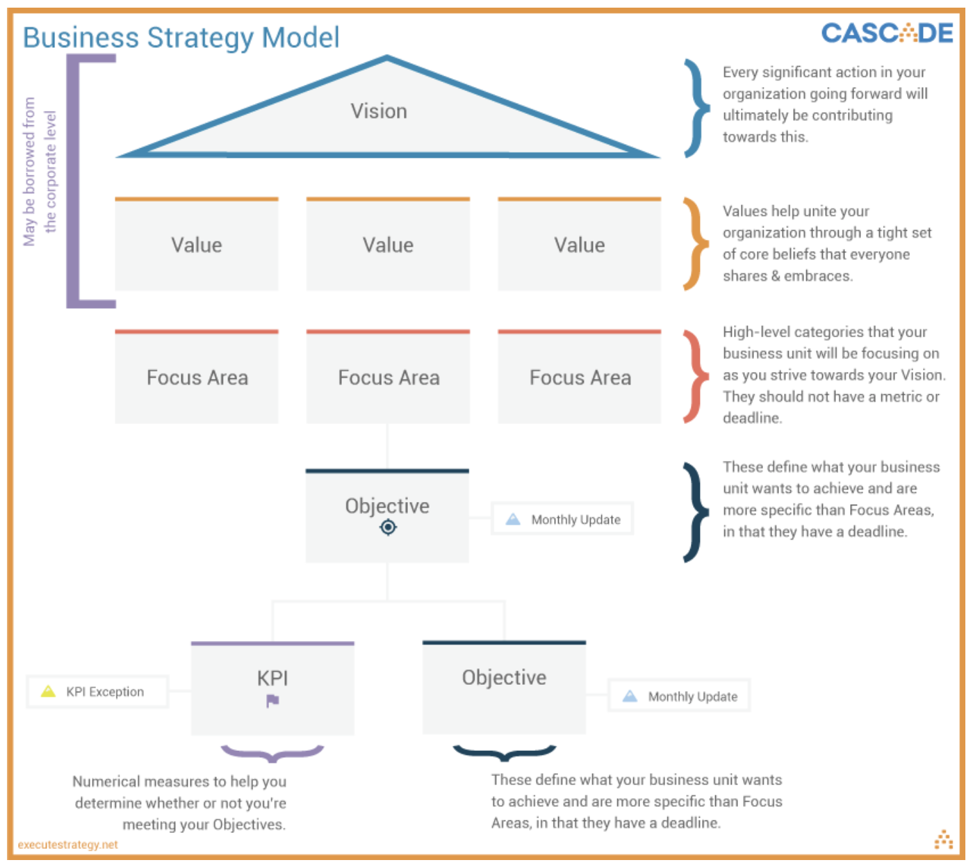
Figure 2: Business strategy model (Wright, 2019).

McKesson vision is to "deliver better health for all" which is aligned by the corporate level of strategy (Hussain, 2019, P1). This mission drives the responsibility effort of the employees to achieve the organisation objectives. Kash et al., reveal that organisational strategy success depends on a defined mission that expected to support the organisation (Kash et al., 2014 pg.252).
The company shared "ICARE" value principle in their higher strategic level, which reflects the shared values in the organisation. ICARE values stand for Integrity, customer-first, accountability, respect and excellence. These values established by Hammergreen to serve as the basis of McKesson cultures and values across the world (Hussain, 2019, P11). Hammergreen realised the importance of shared values to increase the employee's performance and company outcome. This point confirmed by research done in the UK, which showed an increase in project outcome with shared personal values (Rickaby et al., 2017).
McKesson business unit was consisting of three main focused areas, which are the US Pharmaceutical and Speciality Solutions, European Pharmaceutical Solutions, and Medical-Surgical Solutions (Hussain, 2019, P2). Each business unit has its strategy that includes objectives and governance method to maintain the business strategy sustainability (Wright2, 2019). As shown in figure 2, there are two types of objectives in the business strategy, which divided into short-term and long-term objectives (Wright, 2019). McKesson was able to achieve a successful strategic implementation by maintaining the alignment of its employees at a functional department with the business unit's objectives (Hussain, 2019, P6).
Moreover, McKesson invested in other successful small business units such as the practice solutions in business, management, technology, and oncology (Hussain, 2019, P2), which played a rule in increasing the company's revenues by two per cent compared to the previous year (Hussain, 2019, P3).
Further, under each business unit in McKesson, many projects play a significant role in maintaining the growth and sustainability of the organisation. Examples of the successful project run by McKesson were "Biopharma service", "McKesson life science", "McKesson idea share 2018", and the " Own it program" (Hussain, 2019, P6-7).
The key performance indicators are an essential tool to measure the achievement of the business unit objectives (Wright2, 2019). Although McKesson has multiple business units to measure each unit performance, however, they created a smart dashboard to analyse the purchasing history and pharmacological spend data to evaluate the accomplishment of their strategic objectives innovatively (Hussain, 2019, P9).
McKesson believed in their workforce, which contributed to maintaining the company sustainability through enhancing the creativity, motivations and continuous growth of their employees (Hussain, 2019, P5). Strom et al. mentioned that a successful implementation of the strategy requires changing in employee's behaviours and performance, whether performing a new action or make changes in actual performance (Strom et al., 2018). Example of this demonstrated by the usage of advanced technology at McKesson in health data to make the healthcare systems more efficient, from medication prescriptions to increase the accessibility for people to of getting their bills paid online (Hussain, 2019, P2).
Through analysing McKesson strategy using SWOT and PESTLE tools, both revealed important external factors considered crucial for any organisational strategy to deal with, such as Environmental and competitors. In the McKesson CSR strategy that revealed in 2018, McKesson released project of the LED light to maintain the Eco-efficient environment (Hussain, 2019, P7-8). Although McKesson has many competitors at the pharmacological market that may inhibit their revenues and growth, however, their wise partnership project between "McKesson RxCrossroads" with "PANTHERx Speciality pharmacy" and "The Rare Disease Speciality Pharmacy" differentiate its unique pharmaceutical products even with highly precious medications (Hussain, 2019, P5-6).

Factors that strength McKesson strategic business unit:
Upon analysing the strategy of McKesson as an industrial organisation; using both SWOT and PESTLE analysis (Appendix A), we could identify several strength factors that have supported the company strategy. Those factors have reflected positively in the company revenues and let it thrive market competitors (Hussain, 2019, P4). Below, will discuss the strength that has an impact on McKesson development and sustainability.
First strength that McKesson has wide-base established market in the country. It has a considerable market penetrance in the USA; which recognised by being ranked the seventh in FORTUNE 500, the fifth/fourth-largest pharmaceutical company and one-third of all pharmaceutical company are using their products daily (Husssain, 2019, P1). This position has highly empowered the company presence between competitors, allowing a better recognition and purchasing of its products.
Second strength highlighted with McKesson strategy that tightly tied to their vision. The company has launched a "Multi-year strategic growth initiative" to ensure further improvement and sustainability in delivering high quality manufactures that does protect its place in the market (Hussain, 2019, P3). Such a well-studied strategy with clear vision and goals allows better performance and profitable outcomes to the company (Kaplan et al., 2001).
The third strength manifested in McKesson skilful leaders, such as Tyler; the CEO of McKesson-Europe previously and current CEO of McKesson (McKesson cooperation, 2020). He was regularly concentrating on data analysis, evaluation and innovation. He solved many challenges with other leaders, including opioid epidemic (Hussain, 2019, P12). Facing challenges and taking vitals decisions are of the main skills required in a leader (Schoemaker et al., 2019). McKesson has other five skilled leaders who have qualification and leadership skills that are competent to lead the company (McKesson cooperation, 2020).
The fourth strength factor of McKesson is the innovative teams that come up with new products, enter new markets and create the idea of partnership with other in order to enhance the company successes, as they did with Biopharma (Hussain, 2019, P7)

The fifth factor evident with the wise resource investment. McKesson tried to maximize their competencies by concentrating on different fundamental resources of the organization including; human, financial, intangible, structural and physical assets. For instance, human resources; they have a diversified workforce, with people of many geographical, racial, cultural and educational backgrounds that help the company development by bringing in diverse ideas and methodologies of doing things (Hussain, 2019, P4 & P11). One-way of optimizing a physical asset is through using LED lighting across all their locations, which is according to McKesson CEO Hammergren: "Using resources wisely is good for business, and it is good for the environment" (Hussain, 2019, P4).
The sixth strength factor is the usage of different technology in improving the company's revenue. Although, Taylor said in 2019: "McKesson RxO is the missing piece that can help strengthen the relationship between revenue cycle and pharmacy" (Hussain, 2019, P10), however, today McKesson RxO available at McKesson website for business growth consultation on the pharmacological aspect (McKesson corporation, 2020).
The seventh strength factor displayed the presence of McKesson in the international market, such as the European and Canadian market (Hussain, 2019, P4) & (McKesson cooperation, 2020). The advantage of penetrating international market provides a kind of protection against economic cycle risk that might occur in certain countries. Further, it allows benefiting from currency-exchange. In consequence, it maintains the company incomes and sustains its work Productivity (Martinuzzi, 2018).
The eighth factor represented by McKesson brand portfolio, which means the company invest in a variety of products and equipment (Hussain, 2019, P1) & (McKesson cooperation, 2020). Substantial brand portfolio grants great entering of new products to the market because the company's name has already gained the customer's recognition and trust (Fanaras, n.d.). Its products have maintained quality over the years and are still valued by customers, who find it as good value for the amount of money that they pay (Hussain, 2019, P4).
McKesson was preparing for the environmental crisis; which considered as a crucial factor in the organizational strategy. McKesson was able to manage the crisis in 2017 and maintain its distribution even during that time (Hussain, 2019, P5). This factor adds-on to the company trust and reputation.
The tenth strength of McKesson is stimulating the local economic growth of the country by providing a job opportunity for thousands of individuals (DCED, Link between economic growth and employment, n.d.). As well, they considerate employee's well-being as a crucial factor to maintain their effectiveness and productivity. Hammargren said:" We committed more than 14$ million to support charitable causes that matter our colleagues" (Hussain, 2019, P4). A meta-analysis study done across 230 organization showed a strong positive impact on employee well-being with their satisfaction and productivity. Also, it noticed a high level of customer loyalty and a reduction in the turnover rate among employees (Krekel et al., 2019).

Inhibitor factors of McKesson strategic business unit:
Although McKesson strategy has considerable strength that keeps their business sustainable, however, some weakness and challenges reflected negatively on their business market at some points. The weakness of McKesson business strategy divided into internal and external factors, as mentioned in Appendix 1. Internal weakness factors elaborated in the first two points which reflect how it inhibits the company strategic business unit. However, External weakness factors discussed at point three and four, which considered as threats factors that might affect negatively on the strategic business unit sustainability.

The first point is the lack of stuff legislation knowledge on different countries regulations and rules which was related to the tremendous financial loss in litigations of opioids crisis (Hussain, 2019, P10). Legal and regulations of other countries are changeable, and it might reflect in changing or inhibiting the business strategy of the company if the employee does not update themselves with legislation aspect. So, updating staff with countries legal and regulation is crucial to maintain their business unit strategy.

The second weakness is the lack of proper advertising of the company projects, which reflected negatively in being an unknown company worldwide. In consequence, lead to reduce the market cap compared to Apple and Facebook (Hussain, 2019, P3). Although McKesson has different branding portfolios, however, they were not correctly advertising their different projects through social media websites. Thus, affect its yearly revenue because it is not famous as an apple.

The third weakness factor comes from the competitors of other pharmacological companies in the UK and France which contributed to the loss of a customer in these two regions (Hussain, 2019, P5). This threat factor considered as a significant inhibitor factor for any business, whether small or big.

The fourth inhibitor is the environmental factors which may affect the strategic growth of the company, especially if McKesson play a meaningful role in providing their support as what is going nowadays with Coronavirus pandemic status. Although Smith said, “We have redundancies in our supply chain that let us adapt to emergencies” (Hussain, 2019, P6), However, on March 20, 2020, McKesson released in their website about the company inability to provide enough Personal Protective Equipment (PPE) for healthcare worker in the US (McKesson Corporation, 2020).

Opportunities to improve the strategic business unit:
The opportunities for improving the inhibitor factors that affect the strategic units in McKesson presented in this section.

The first improvement step for McKesson to maintain and improve their unit strategy is improving the usage of advertising technology. Which means, the company need to invest more in technology that will help in increasing its advertising like utilizing social media applications such as Facebook, Twitter and Instagram. In 2017, a Study highlighted the positive relationship between advertising and business growth and customer buying behaviours (Haider & Shakib, 2017).

Another improving opportunity for McKesson to maintain their business growth is providing online resources market to increase their customer’s number and satisfaction. Saura et al. mentioned in their article about digital marketing for sustainable business growth, the internet becomes a crucial factor in the business growth of the company mainly, if it was easily accessible and available most of the time for the customer; Such as Amazon that is available for 24 hours in 7 days per week with international delivery services. Further, Online technology now used widely on data collection and analysis for sustainable company improvement, especially their internal strategy (Saura et al., 2020) & (Amazon website, 2020).

Further, Although McKesson entered the European market, if they invest in the Asian market, they will open a new channel of marketing with fewer competitors. For Example, The Gulf Region have little competitive pharmacological companies as well as the surgical-medical equipment companies, which will make McKesson as the leading supplier of medications and medical equipment with apparently fewer Taxes.
The Conclusion:
Although McKesson has a great designed business unit strategy, it faces some inhibitors and threats factors that may affect its growth and development. However, Taylor, the CEO with other leaders of the company, advanced power enormously to the current strategy to master the obstacles that may inhibit the company expansion as demonstrated before with the ten strength factors. Finally, each business has opportunities to develop, and McKesson has some gaps that necessitate the modifications to reach the rank of a reliable company world-wide.
References:

Amazon.com (2020). About amazon: Sustainability. Retrieved from: https://www.aboutamazon.com/?utm_source=gateway&utm_medium=footer

Fanaras, L. A. (n.d.). 5 Major Benefits of a Strong Brand. Retrieved from: https://mill.agency/creative/5-major-benefits-strong-brand/

Haider, T. & Shakib, Sh. (2017). A Study on the Influences of Advertisement on Consumer Buying Behavior. Business Studies Journal, 9(1). Retrieved from: https://www.abacademies.org/articles/a-study-on-the-influences-of-advertisement-on-consumer-buying-behavior-7177.html

Kaplan, R.S., & Norton, D. P. (2000) The Strategy-Focused Organization: How Balanced Scorecard Companies Thrive in the New Business Environment. Harvard Business School Press.

Kash, B. A., Spaulding, A., Gamm, L. D., & Johnson, C. E. (2014). Healthcare Strategic Management and the resource-based review. Journal of Strategy and Management, 7(3), 251-264. DOI: 10.1108/JSMA-06-2013-0040

Krekel, C., Ward, G., & De-Neve, J-E. (2019). Employee Wellbeing, Productivity, and Firm Performance. Saïd Business School WP 2019-04. Retrieved from: http://dx.doi.org/10.2139/ssrn.3356581

Martinuzzi, B. (2018). What Are the Advantages of International Trade? Retrieved from: https://www.americanexpress.com/en-us/business/trends-and-insights/articles/advantages-international-trade/

McKesson corporation website (2020). Retrieved from: https://www.mckesson.com

Rickaby, M., Glass, J., Mills, G., & McCarthy, S. (2017, Septemper) Exploring Alignment of Personal Values in a Complex, Multi-Organisation Construction Project Environment. In P. Chan, & C. Neilson, (Eds.), The 33rd Annual ARCOM Conference, (pp. 94-103). Cambridge, UK: Association of Researchers in Construction Management. retrieved from: https://discovery.ucl.ac.uk/id/eprint/10053302/1/Rickaby-Glass-Mills-McCarthy__2017___ARCOM.pdf

Saura, J. R., Sanchez, P. P., & Herráez, B. R. (2020). Digital Marketing for Sustainable Growth: Business Models and Online Campaigns Using Sustainable Strategies. Retrieved from: http://web.a.ebscohost.com.uaeu.idm.oclc.org/ehost/pdfviewer/pdfviewer?vid=1&sid=e7c751a6-da29-4701-a5c2-195a2c784c6b%40sessionmgr4006

Schoemaker, P. J. H., Krupp, S., & Howland, S. (2013). Strategic Leadership: The Essential Skills. Harvard Business Review. Retrieved from https://hbr.org/2013/01/strategic-leadership-the-esssential-skills

Strom, L. C. L., Willumsen, P. L., Heck, O., & Heck, J. (2018). Can design thinking mitigate critical strategy implementation risks. International design conference (2018), 1233-1244. Retrieved from: https://www.designsociety.org/download-publication/40531/CAN+DESIGN+THINKING+MITIGATE+CRITICAL+STRATEGY+IMPLEMENTATION+RISKS%3F

The Doner Committee for Enterprise Development. (n.d.). Link between economic growth and employment. Retrieved from: https://www.enterprise-development.org/what-works-and-why/evidence-framework/link-between-employment-and-economic-growth/

Wright, T. (2019, Augest). How to Create a Winning Business Level Strategy. Retrieved from: https://www.executestrategy.net/blog/business-level-strategy

Wright², T. (2019, July). Strategic Planning Models: 3 Awesome Examples. Retrieved from: https://www.executestrategy.net/blog/strategy-planning-models

